**Build and run instructions of Oracle Coding Challenge**

For this challenge, I am using the Oracle Database Express and SQL Developer to write my code.

<https://www.oracle.com/uk/database/technologies/appdev/xe/quickstart.html>

<https://www.oracle.com/tools/downloads/sqldev-downloads.html> (Windows and Mac version)

**Instructions**

1. Create a new user by using user “sys” and grant the privileges to the new user.

***create_user_privileges.sql***

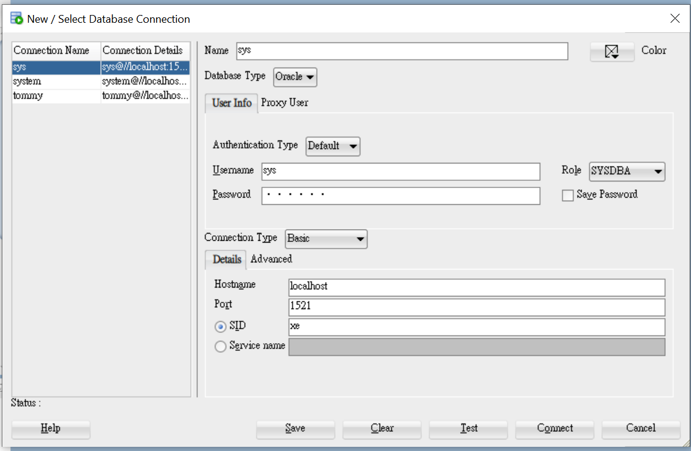

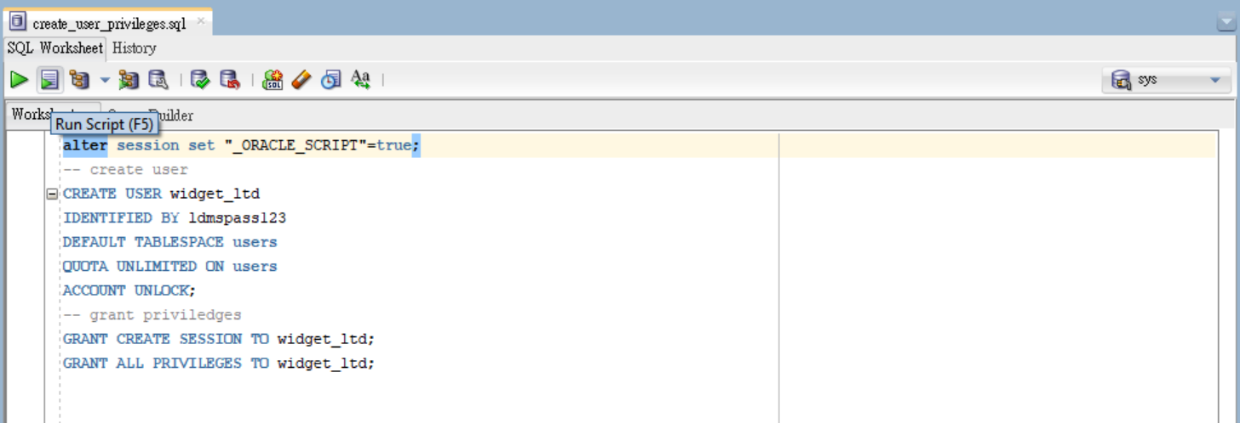

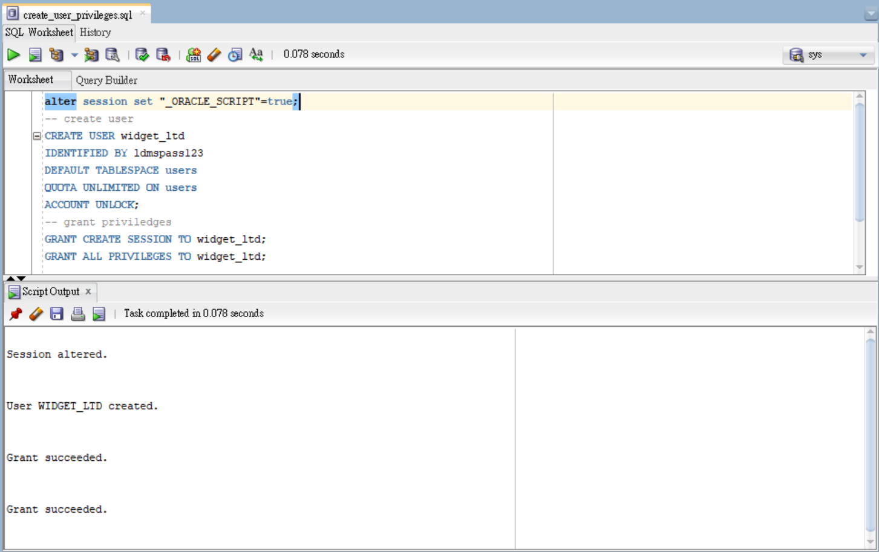

1. Create tables Departments and Employees

***create_tables.sql***

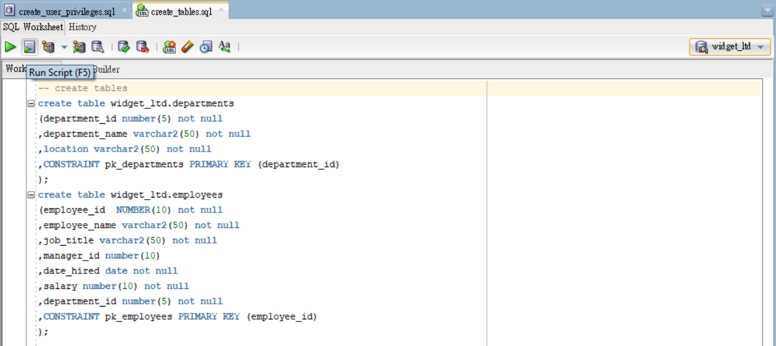

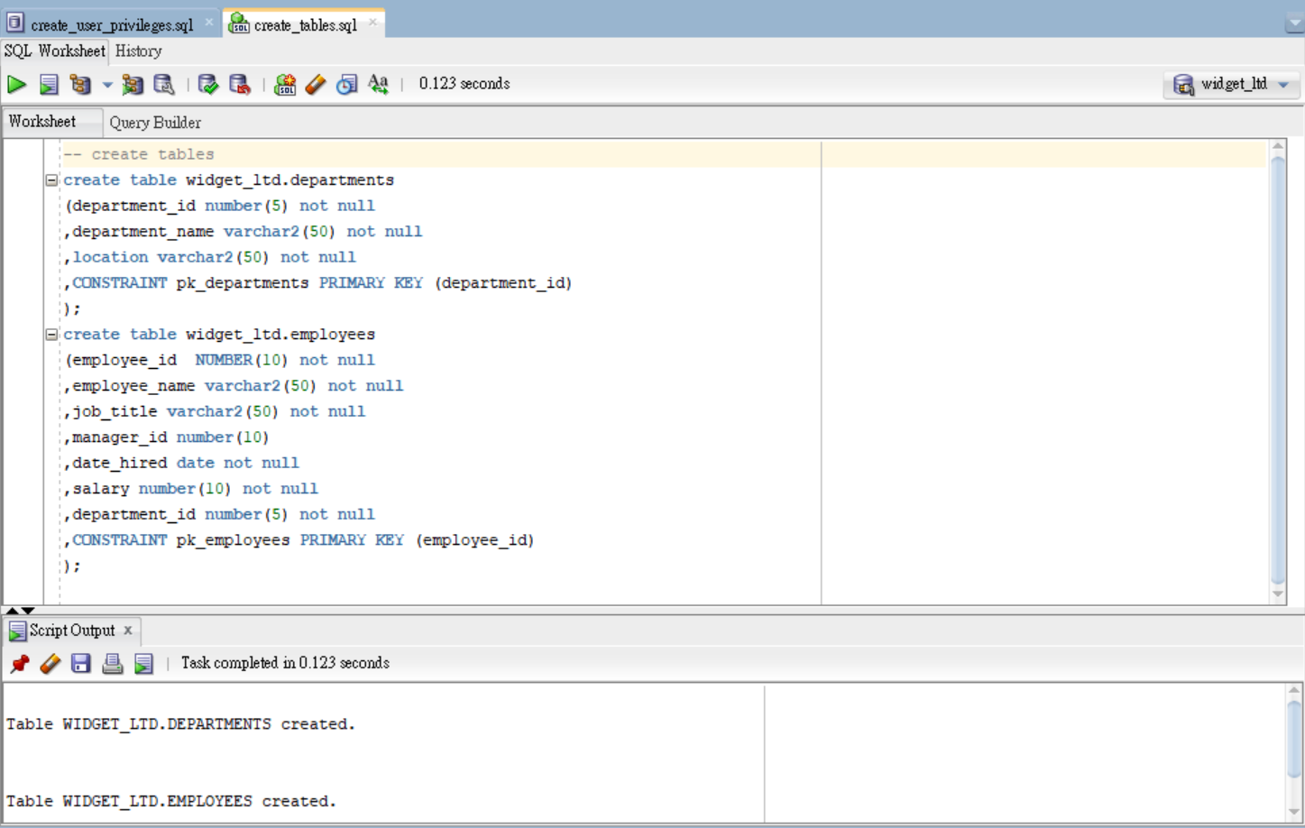

1. Compile the function of create employee

***insert_employee.fun***

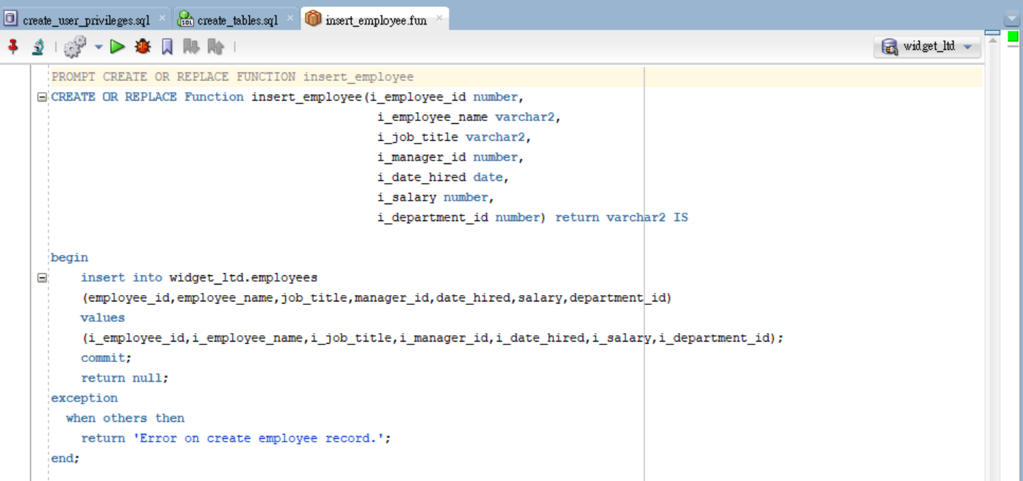

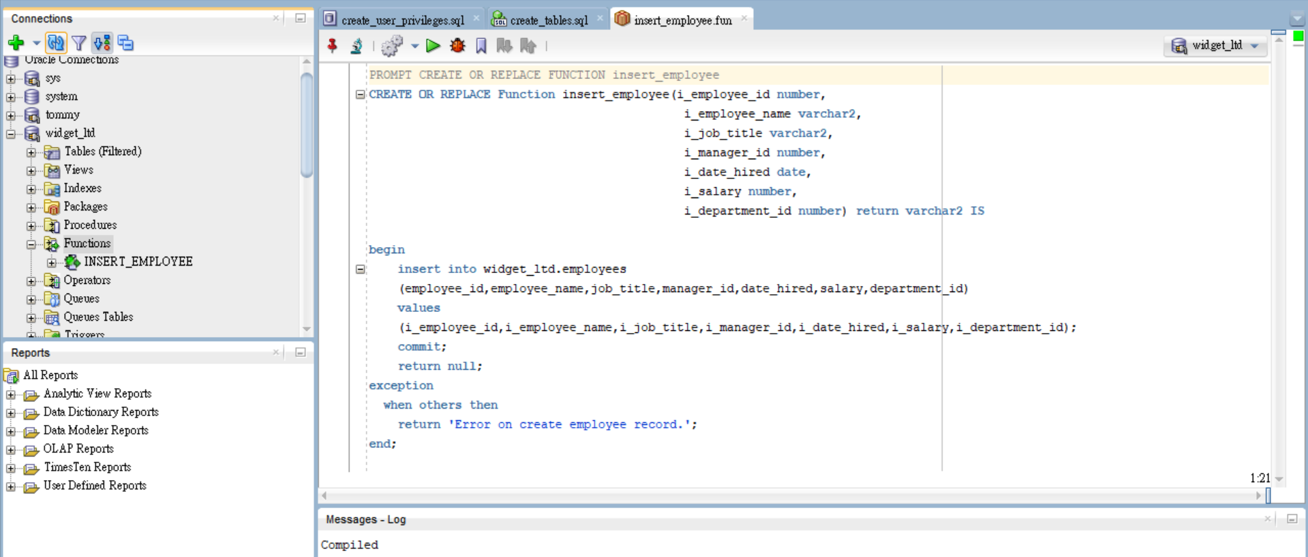

1. Insert employee data provided to table

***Insert_employee.sql***

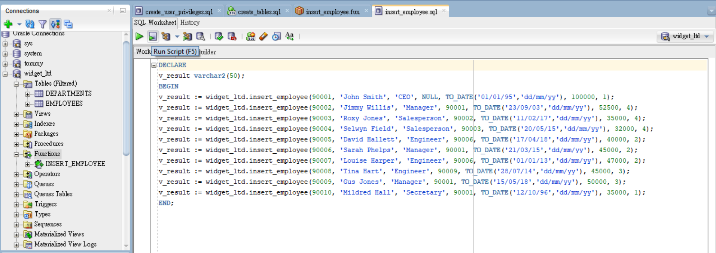

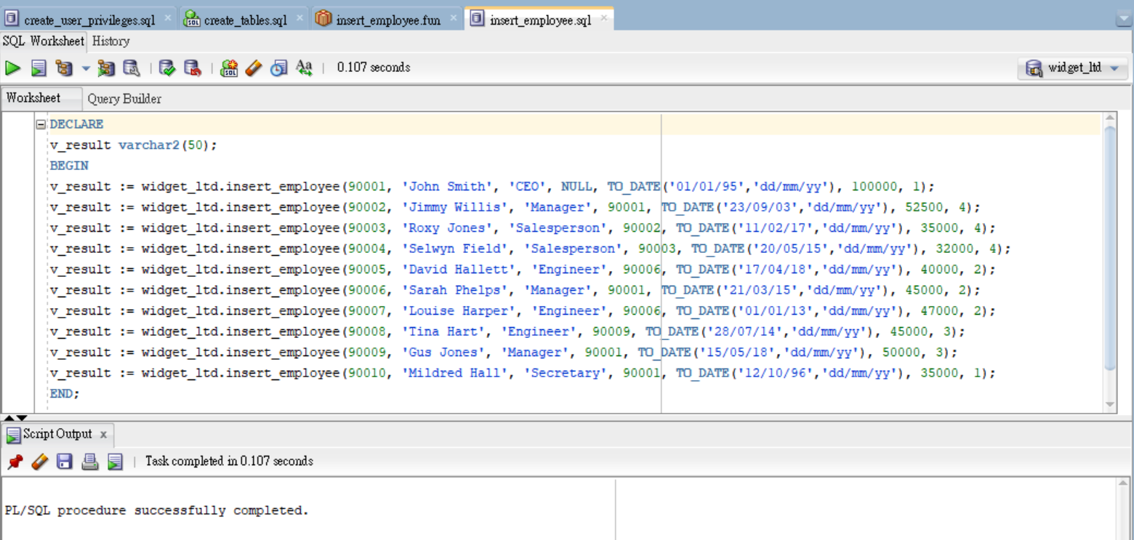

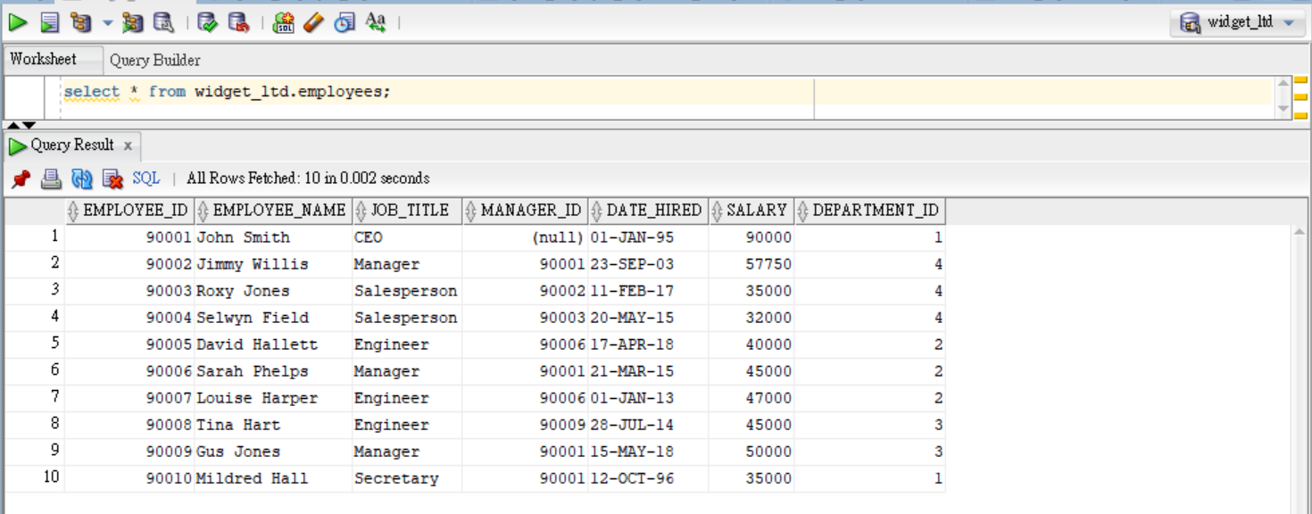

1. Compile the function allow the Salary for an Employee to be increased or decreased by a percentage

***update_employee_salary.fun***

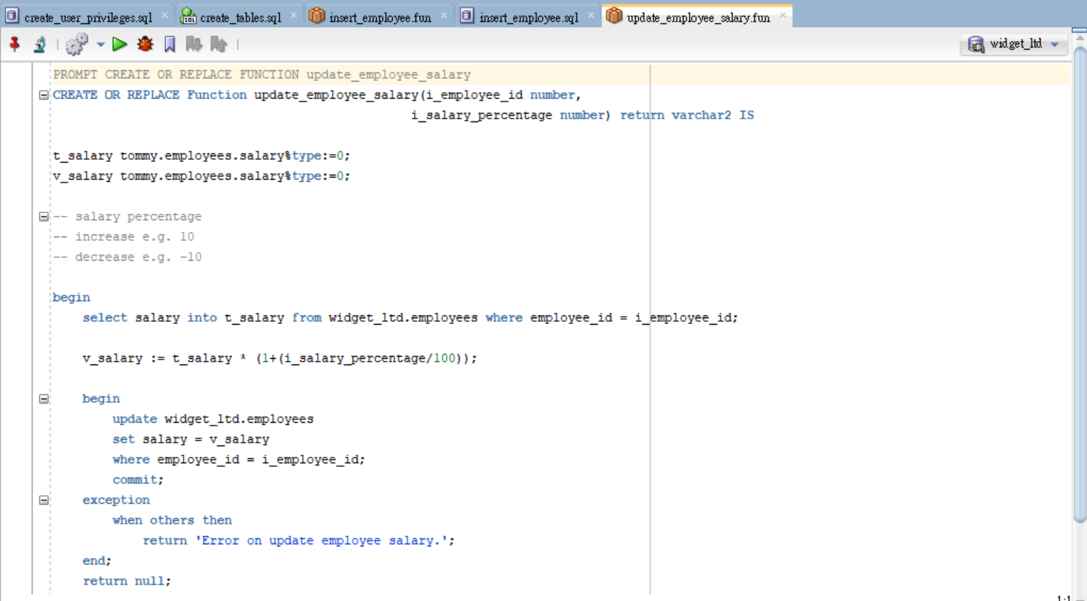

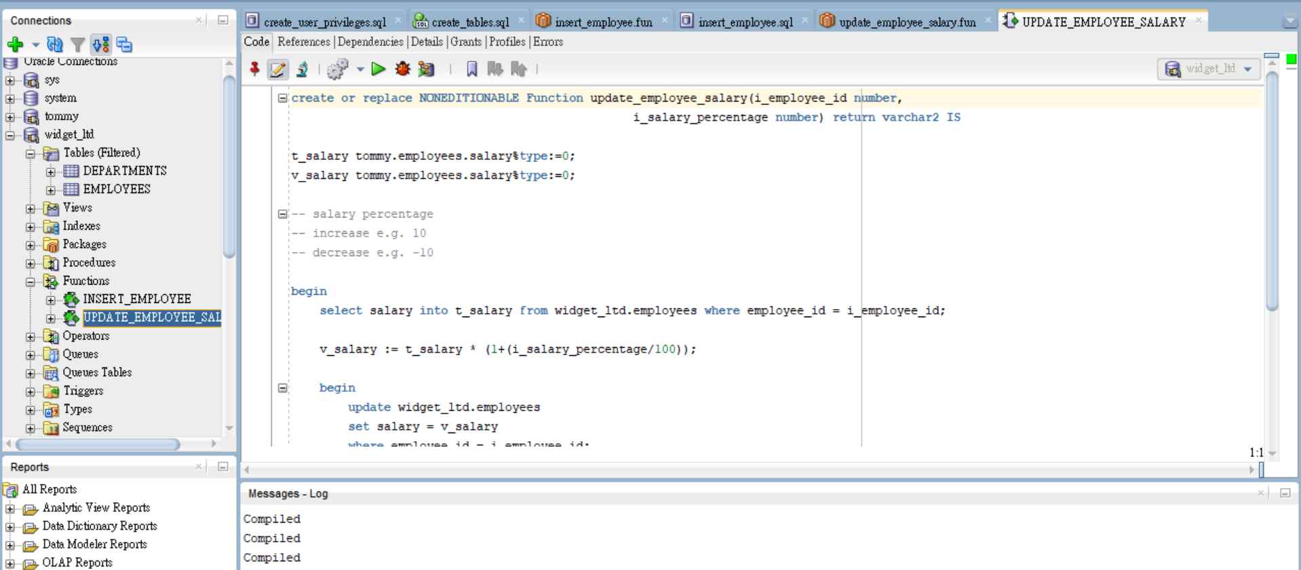

Test the salary update function

Before update salary

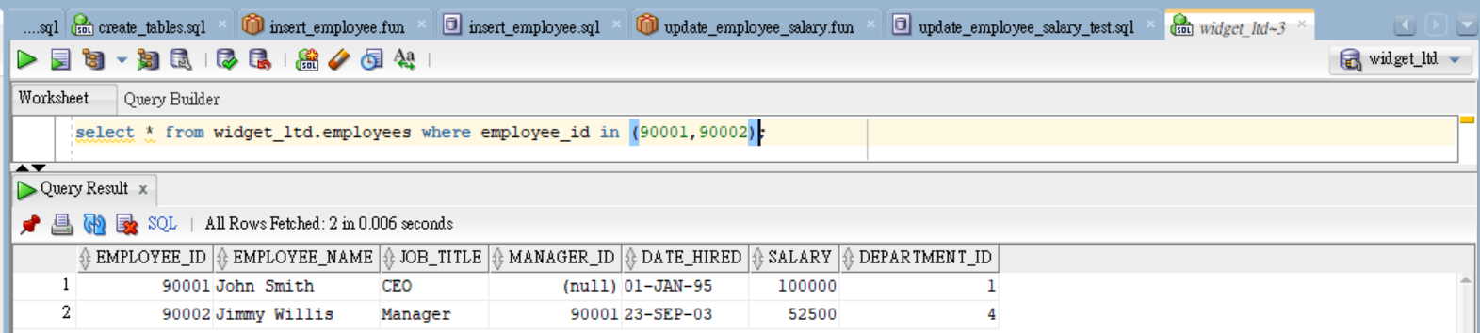

Update salary

***update_employee_salary_test.sql***

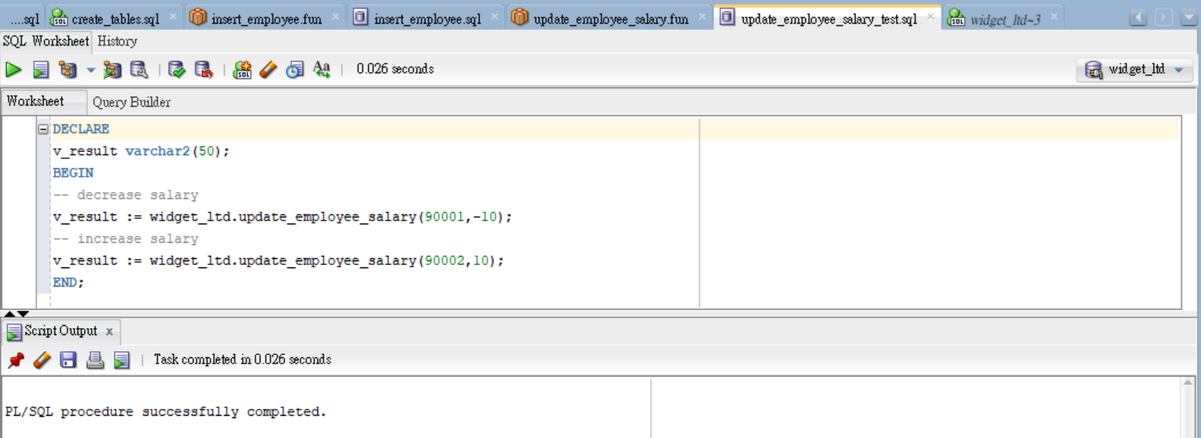

After updated salary

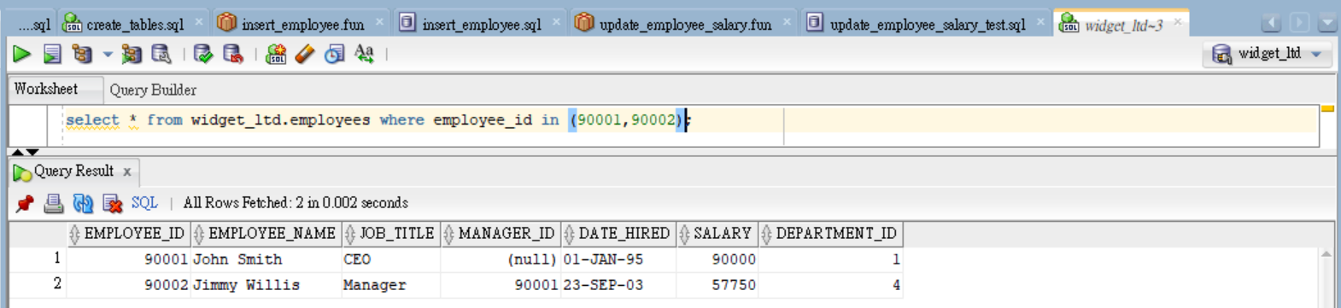

1. Compile the function for create department

***insert_department.fun***

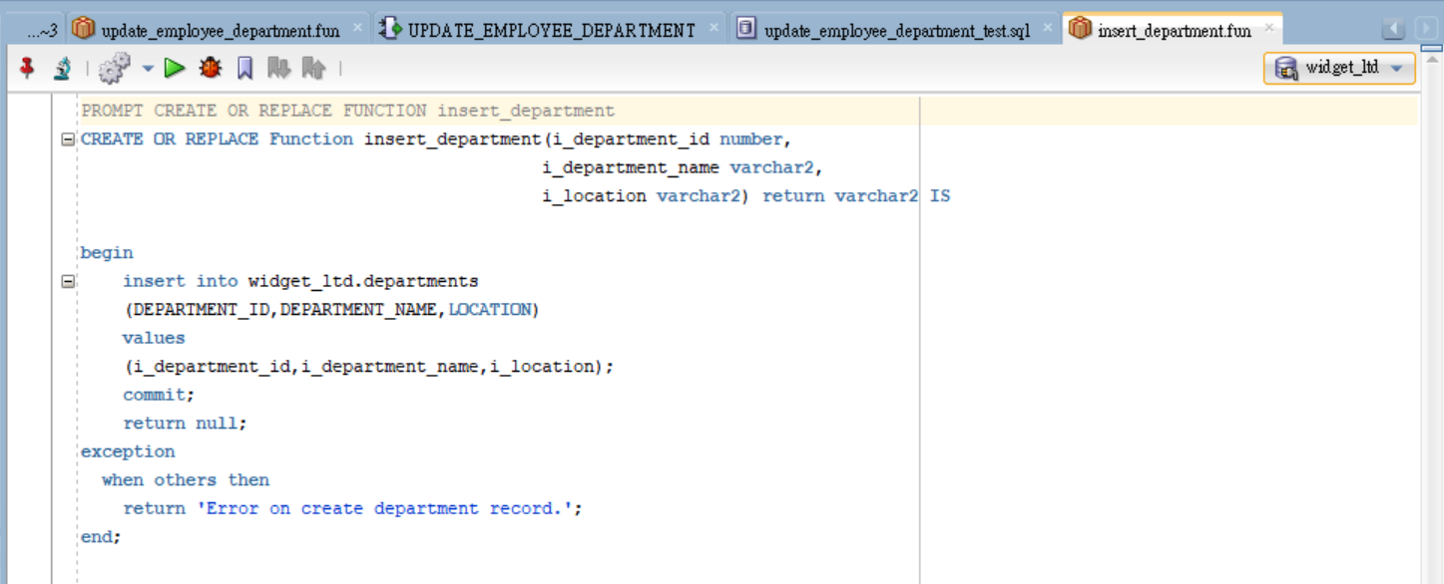

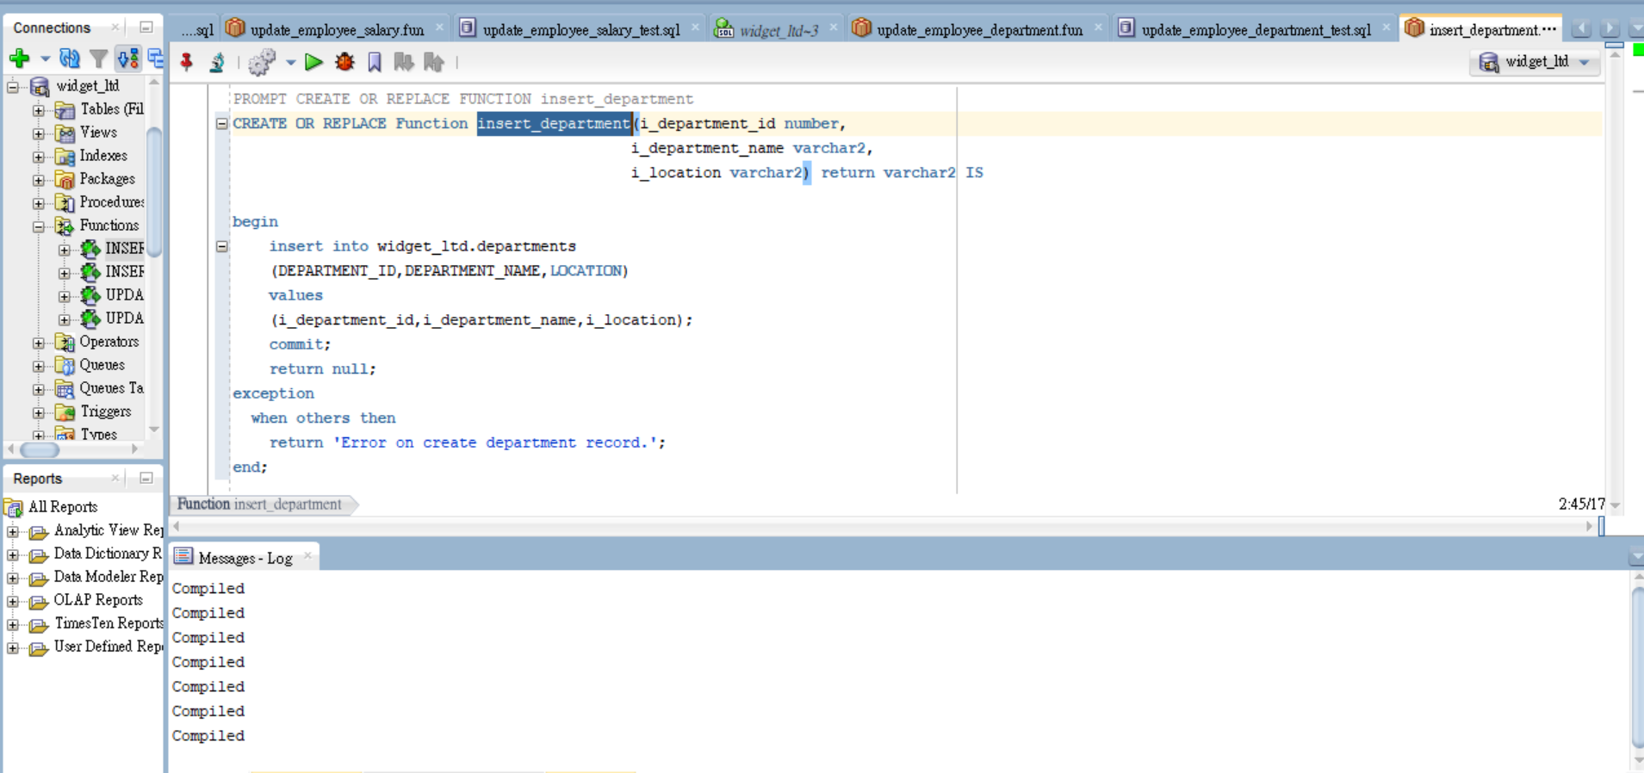

1. Insert department data provided to table

***insert_department.sql***

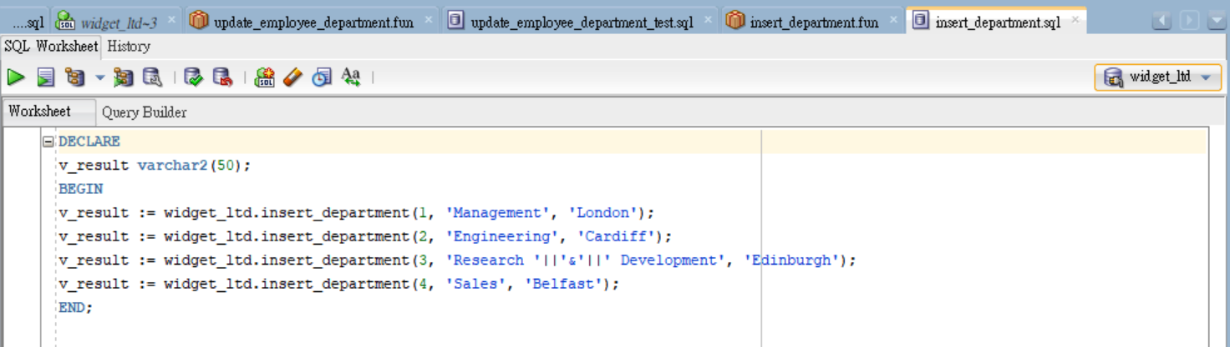

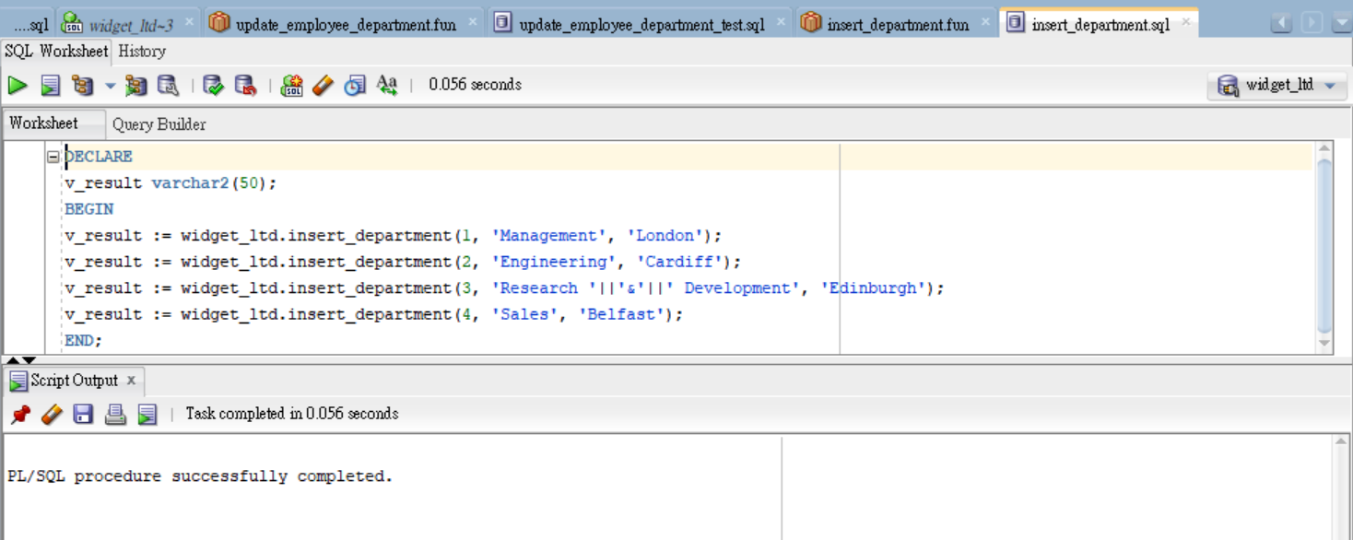

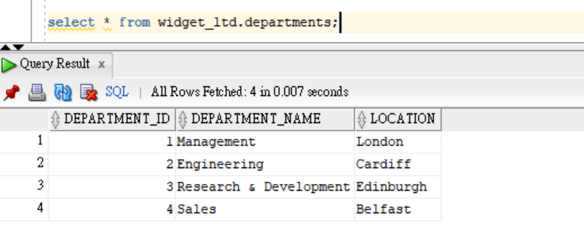

1. Compile the function for transfer of an Employee to a different Department

***update_employee_department.fun***

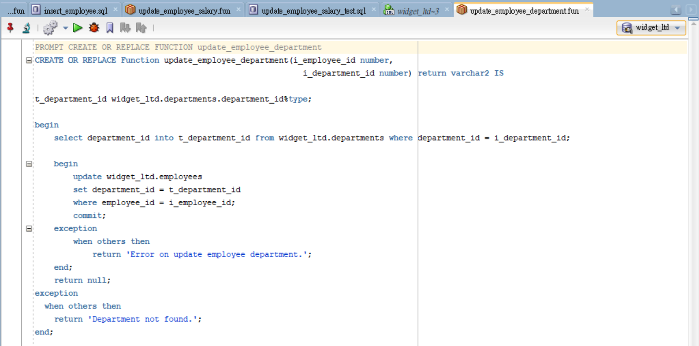

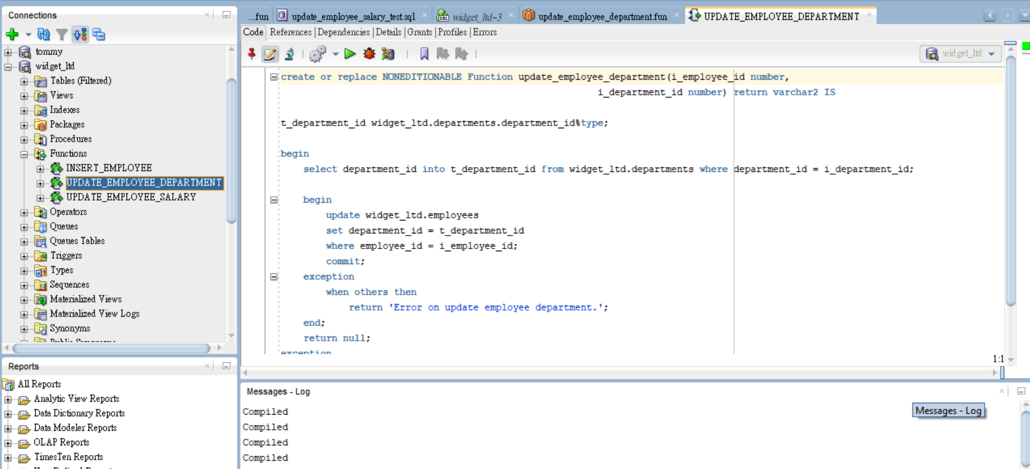

Test the department update function

Before department update

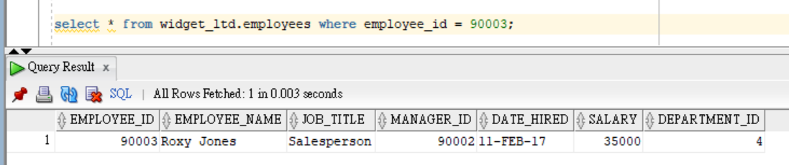

Update department

***update_employee_department_test.sql***

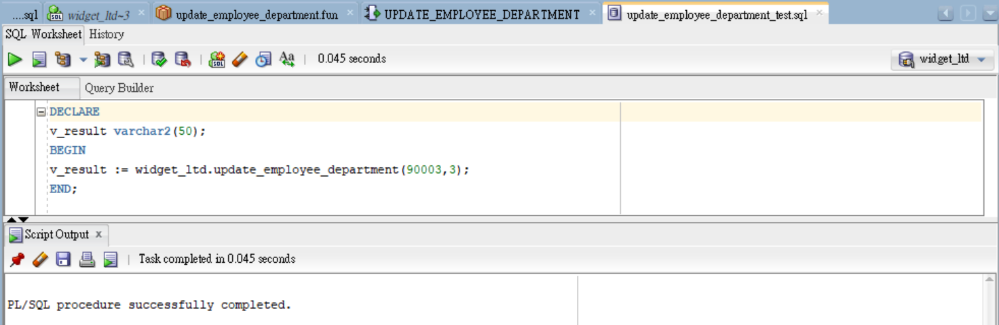

After department updated

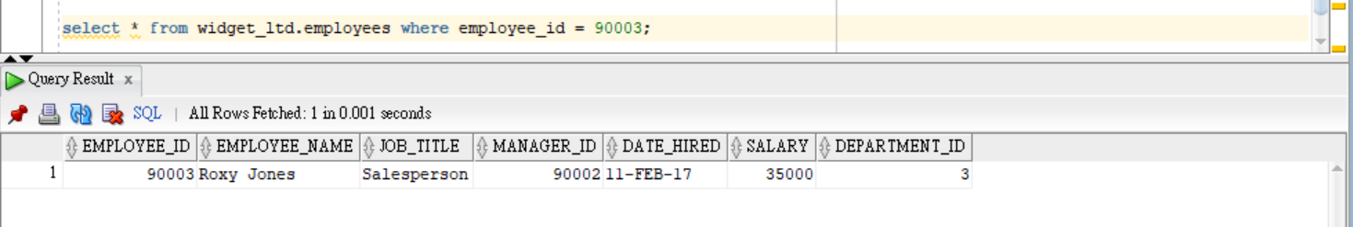

1. Compile the function for return the Salary of an Employee

***get_employee_salary.fun***

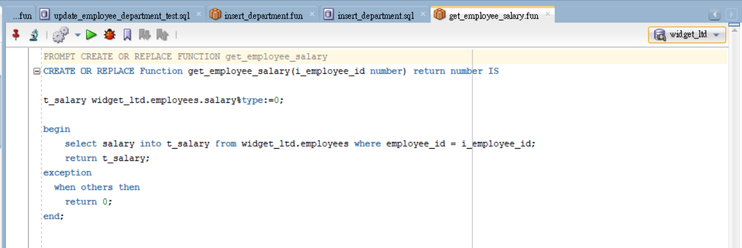

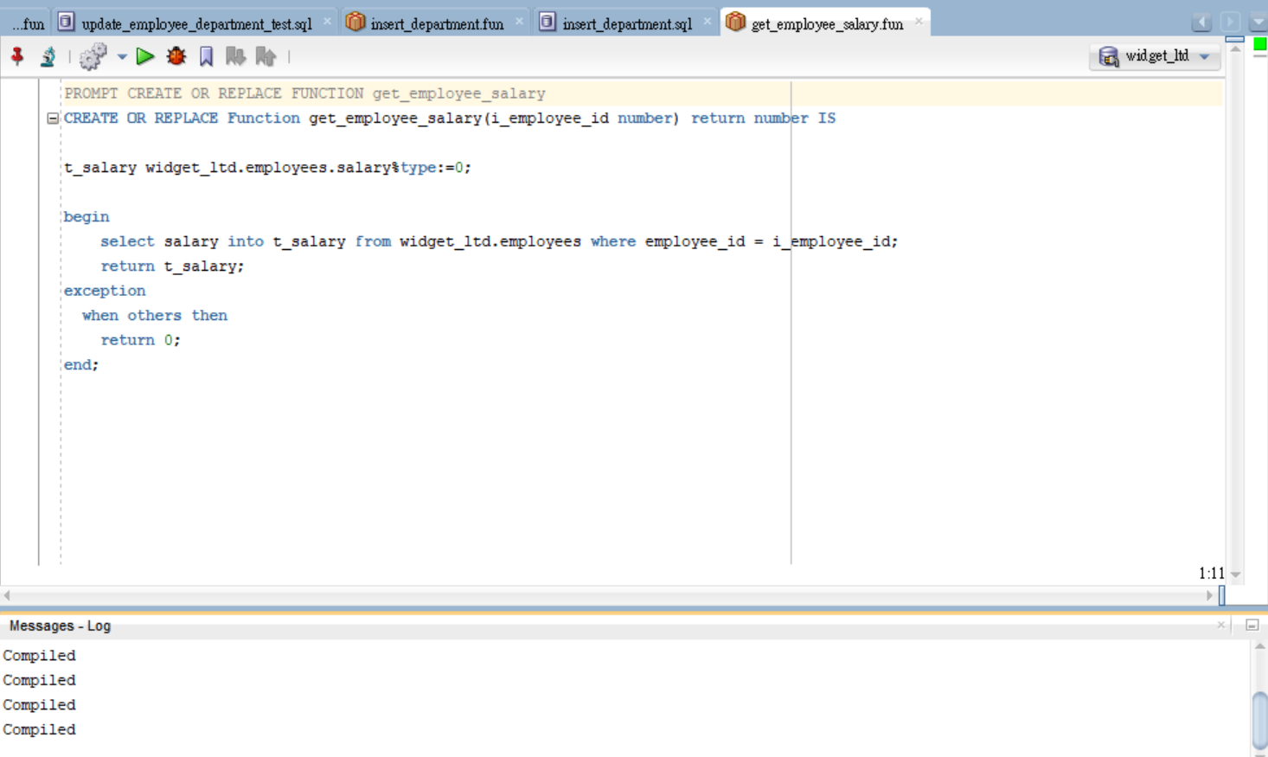

Test the get salary function

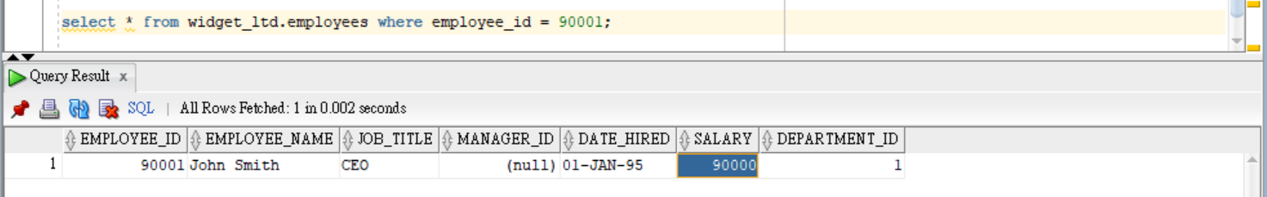

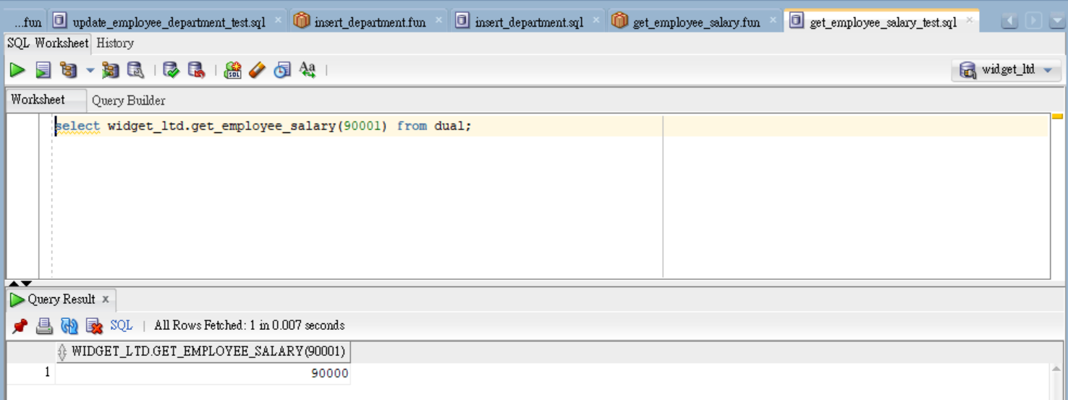

1. Report shows all Employees of a Department

***get_report_department_employee.sql***

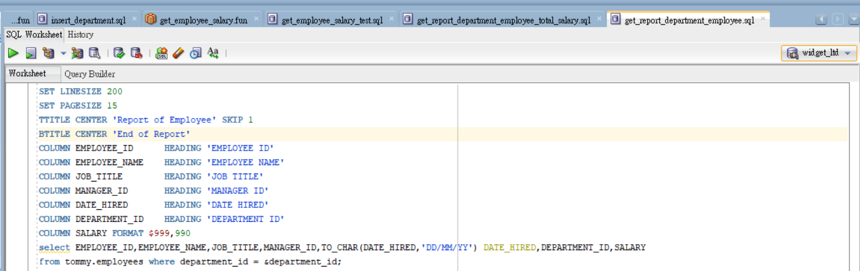

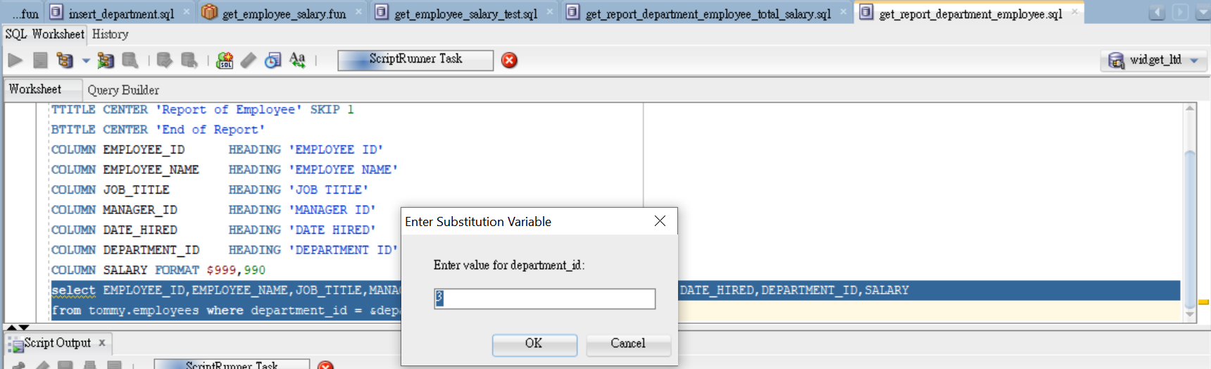

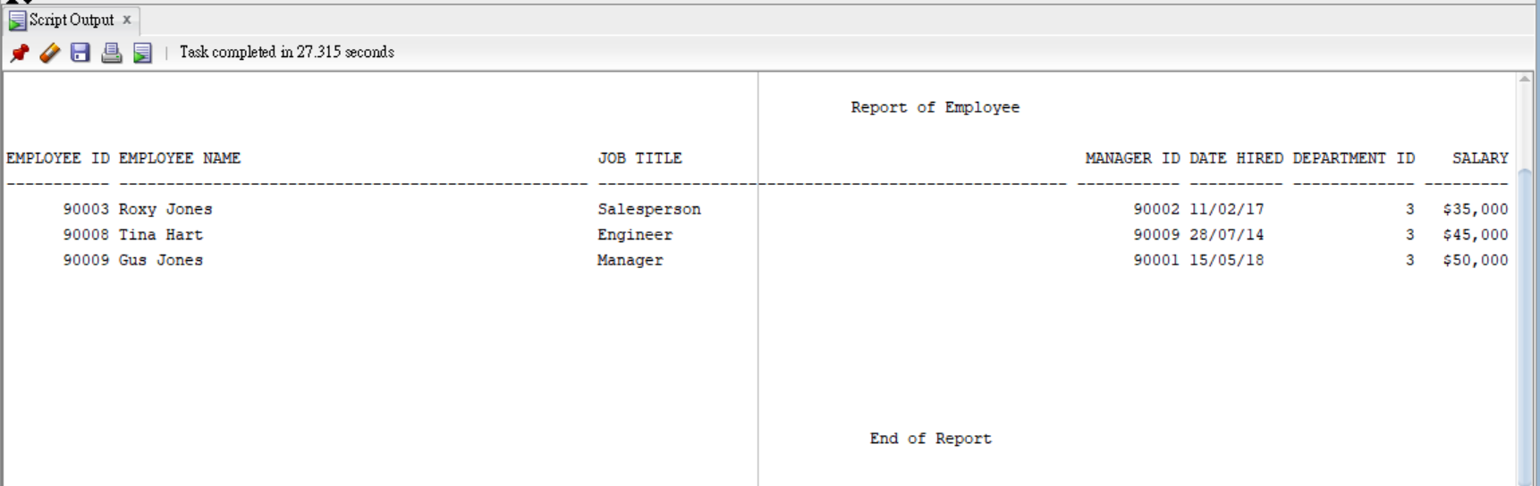

1. Report shows the total of Employee Salary for a Department

***get_report_department_employee_total_salary.sql***

